**PARENTS SHOULD BE A POSITIVE INFLUENCE**

## How badly you must want to win, Not for yourself but me,

So help me play this game, dear Mom & Dad, With dedication, goals and dignity.

It’s embarrassing for me, Mom & Dad, When you criticize my coach,

If you think you can be helpful, Then try a new approach.

Call and make arrangements, To meet my coach face to face, Far better than to yell at coach In such a public place.

I think that you will also find, Your friendship will be sealed,

In a more conductive atmosphere, Than on the playing field.

Please try to go along with coach, Not judging wrong or right.

You know they have a job to do, That must be done tonight.

As my coach stands alone down there, In front of all the fans,

Help them do the job they must, By staying silent in the stands. Snap decisions they must make, Under pressure of the game,

And certainly where you must sit, Tis’ not really quite the same. Even when they call it right,

I often make a mistake,

That surely makes them look as though Their coaching is at stake.

Sometimes I’ll be scolded, Then get a pat on the back, And I will get it next time, You can count on that.

My coach will take the blame for losses And walk out on a limb,

But our team will get credit For each and every win.

So be there when I need you, Mom & Dad.

Shout encouragement to me.

***Author Unknown***

**A PARENT-COACH COMMUNICATION GUIDE**

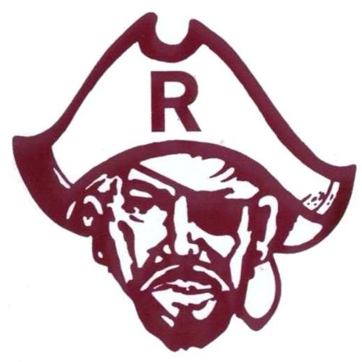

**PREPARED BY:**



Both parenting and coaching are extremely difficult vocations. By establishing commu- nication and understanding of each position, we are better able to accept the actions of the other and provide greater benefit to our student athletes. To be successful, communication is vital and requires involvement, dedication, sacrifice, and commitment from parents, student athletes, and coaches.

### COMMUNICATION YOU SHOULD EXPECT FROM YOUR CHILD’S COACH

1. Coach’s and program’s philosophy.
2. Individual and team expectations.
3. Location and times of all practices and games.
4. Team requirements, i.e., practices, special equipment, off season conditioning.
5. Procedure followed should your child be injured during practice or games.
6. Any discipline that may result in the denial of your child’s participation.

### COMMUNICATION COACHES EXPECT FROM PARENTS

1. Concerns expressed directly to the coach.
2. Notification of schedule conflicts well in advance.
3. Specific concerns with regard to a coach’s philosophy and/or expectations.
4. Support for the program and the attributes of dedication, commitment, and responsibility that are ingredients for success and excellence. Encourage your child to excel.

While your child is involved in interscholastic athletics, they will experience some of the most rewarding and inspiring moments of their lives. It is also important to understand that there might also be times when things do not go the way you or your child wishes. At these times, discussion with the coach is encouraged.

### APPROPRIATE CONCERNS TO DISCUSS WITH COACHES

1. The treatment of your child, mentally and physically.
2. Ways to help your child improve and develop.
3. Concerns about your child’s behavior.

It is very difficult to accept your child not playing as much as you may hope. Coaches are professionals. They make judgment decisions based on what they believe is best for the team and all athletes involved. There are certain areas and issues that can and should be discussed with your child’s coach. Other things, such as those below, should be left to the direction of the coach.

### ISSUES NOT APPROPRIATE TO DISCUSS WITH COACHES

1. Playing time
2. Team strategy
3. Play calling
4. Other student athletes

### IF YOU HAVE A CONCERN TO DISCUSS WITH A COACH

1. Call to set up an appointment with the coach.
2. If the coach cannot be reached, call your AD. A meeting will be set up for you with the coach.
3. Please do not attempt to confront a coach before, after, or during a practice or game. These can be emotional times for both the parent and the coach, and this situation does not promote resolution nor objective analysis.

### WHAT A PARENT CAN DO IF THE MEETING WITH THE COACH DOES NOT PROVIDE A SATISFACTORY RESOLUTION

Call and set up an appointment with the AD to discuss the situation.

Research indicated that students involved in athletics are most likely to succeed at their chosen profession and make creative contributions to their communities. Many of the character traits, qualities, and attributes required to be a successful student athlete are exactly those that will promote a successful life after high school.

### FIVE TIPS FOR IMPROVING PARENTAL INVOLVMENT

Parents are a powerful part of any athletic program. Positively involved parents can help any team or athletic program achieve its goals much more effectively. On the other hand, alienated or uninvolved parents can be devastating to an athletic endeavor. Here are some tips for improving parental involvement that can apply to either an individual team or an entire athletic department:

1. Get to Know Your Parents
2. Set Your Expectations Up Front
3. Encourage Parents to Take Ownership in the Program
4. Make Parents Feel Special
5. Recognize That You are Dealing With Someone’s Child

One of the best ways to achieve many of these goals is a preseason meeting. Hold a meeting before each of the sports seasons and discuss general athletic policies. The coach then meets with the parents of his or her individual team, allowing coaches to put together parents’ faces with their children. The parents have the opportunity to hear the requirements up front and to ask questions. So many parent conflicts arise out of uncertainty and miscommunication, so take as many steps as possible to avoid these pitfalls. You will soon find that parents are working with you, not against you.

### WHAT ARE THE BENEFITS OF PARTICIPATION IN HIGH SCHOOL INTERSCHOLASTIC ATHLETICS?

*Athletics support the academic mission of schools.* They are not a diversion but rather an extension of a good educational program. Students who participate in athletic pro- grams tend to have higher grade-point averages, better attendance records, lower drop-out rates and fewer discipline problems than students generally.

*Athletics are inherently educational.* Athletic programs provide valuable lessons on many practical situations—teamwork, sportsmanship, winning and losing, hard work. Through participation in athletics, students learn self-discipline, build self-confidence, and develop skills to handle competitive situations. These are qualities the public expects schools to produce in students so that they become responsible adults and productive citizens.

*Athletics foster success in late life.* Participation in high school athletics is often a predictor of later success—in college, career, and becoming a contributing member of society.

### HIGH SCHOOL ATHLETICS—A REALITY CHECK

In the NCAA First Team Publication, “What Time Is It” (Volume II) statistics rela- tive to the estimated probability of competing beyond high school were cited. For example, of almost 550,000 male high school basketball players, 2.9% will play at the NCAA level, 1.3% of NCAA players will go to professional, and 0.03 of high school players ultimately go to play professionally. These percentages are similar in women’s basketball, football, baseball, ice hockey and soccer. Bottom line, you have a far greater chance of attaining an academic schol- arship than of doing so in athletics. In fact, for the vast majority of high school student athletes, they will not participate in NCAA athletics at any level.